MEMO

From | OC VQU |  |  | To | Error: Reference source not foundAll OC Units
 |  |  |  | CC | DCO Trg and OC Trg Gp
Ref. | VQU/S/3B/2021 |  |  | Date | 23 March 2021Error: Reference source not found

HKIAA’s Easter Virtual Tour
Our members are highly encouraged to attend a virtual tour organised by the Hong Kong International Aviation Academy (HKIAA) with details below:

Title: | Easter Virtual Tour (復活節航空遊學團)
Date: | 9 April (Friday)
Time: | 10:00a.m. – 16:30p.m.
Content: | HKIAA’s message: “Easter is just around the corner! Join us on a one-day virtual tour to feed your travel cravings at the comfort of your own home!  Set off on a journey with Hong Kong Airlines pilots and aircrews to discover know-how of different flight stages from ground to take off and climb, cruising, to approach and landing. You may not be able to fly at the moment, but don’t let it stop you from spreading your wings. Stay home, Stay hungry and Stay passionate! Sign up now for a FREE aviation learning journey!”  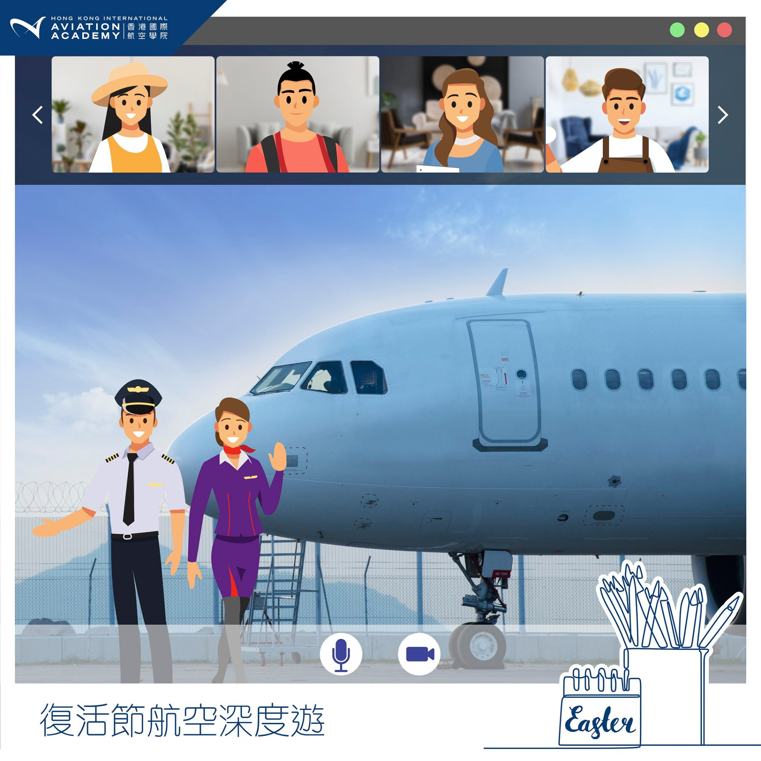
Application Method: | Online registration: https://bit.ly/38V2pXc  Deadline: 10:00a.m, 29 March 2021
Disclaimer: | This seminar is NOT organized by VQU so this memo is provided for informational purposes only.

Should you have any queries, please do not hesitate to contact the event organizer (academyenquiry@hkiaaacademy.com) directly.

Winnie S Y Ho
Ag Sqn Ldr
OC VQU

